FACTOR ANALYSIS



**Component Matrix**

|  |  |  |  |  |  |
| --- | --- | --- | --- | --- | --- |
|  | 1 | 2 | 3 | 4 | 5 |
| price | .665 | .411 | .322 | -.068 | .214 |
| bedrooms | .720 | .266 | -.349 | .204 | -.336 |
| floors | .563 | -.444 | .283 | .161 | .451 |
| waterfront | .126 | .290 | .695 | -.501 | -.258 |
| condition | -.178 | .666 | -.332 | -.210 | .499 |
| zipcode | -.303 | .251 | .469 | .739 | .025 |
| new_bathrooms | .910 | .128 | -.153 | .148 | -.124 |
| yr_built (Binned) | .515 | -.686 | -.006 | -.178 | .082 |
| sqft_living (Binned) | .883 | .204 | .017 | .017 | .051 |

Extraction Method: Principal Component Analysis.

a 5 components extracted.

We have to explain why we choose only 3 factors instead of 4.

We highlights in our new factors the most important components for each one. For factors number 5 we don’t have any very important component then the others.

2STEP CLUSTER ANALYSIS

|  |  |  |  |  |
| --- | --- | --- | --- | --- |
| **Cluster** | **percent(values)** | **percent(values)** | **V4** | **V5** |
| 1 | 0.819 | 177 | 1 | 0.8189515569333272 |
| 2 | 13.3253 | 2,880 | 2 | 13.325313468745662 |
| 3 | 18.4657 | 3,991 | 3 | 18.465738213112477 |
| 4 | 27.2197 | 5,883 | 4 | 27.21972886688567 |
| 5 | 22.3292 | 4,826 | 5 | 22.329153750057834 |
| 6 | 17.8411 | 3,856 | 6 | 17.841114144265024 |



With the 2Step analysis we try find the best number of clusters. The algorithm give us as the best choice K = 6. Analysing the Silouhette graph we can see that the quality of the clusters is not very good, but this is the best result we could get from this dataset.

K-MEANS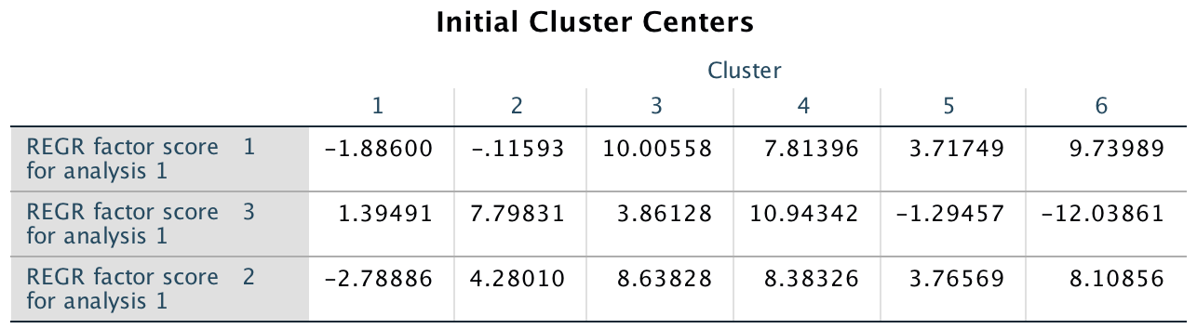

We did the analysis considering the first 3 factors we found with the factor analysis

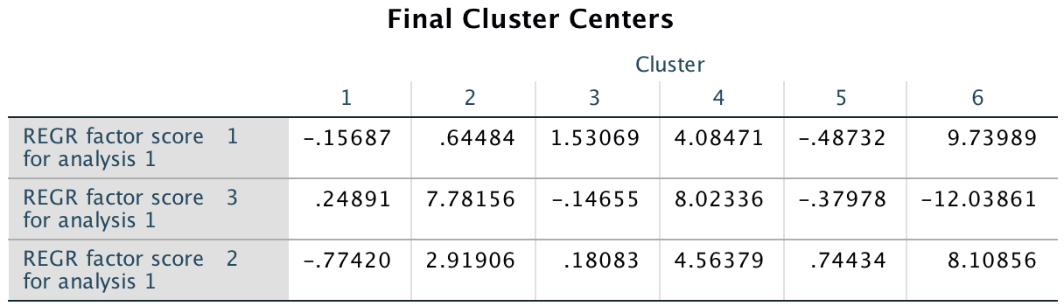

We have to explain and describe the cluster. We think that for example Cluster 4 and 6 has the huge amount of bathroom bedrooms and maybe they are big houses, because in the factor analysis we found that factors 1 is more correlated to bedrooms, bathrooms and sqft_living.

All the 3 factors are significant.

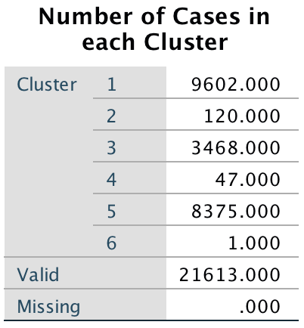

In particular, for CLUSTER 6 the observation is the n° 15871. We present now the value for this one

|  |  |  |  |  |  |  |  |  |
| --- | --- | --- | --- | --- | --- | --- | --- | --- |
| Price | Bedroom | Sqft_liv | Floors | Waterfront | Condition | Year | Zipcode | Bathrooms |
| 6.4E+005 | 33 | 1620 (group n°7) | 1.0 | 0 | 5 | 1947  (group n° 4) | 98103 | 58.00 |

|  |  |  |
| --- | --- | --- |
| Factor 1 | Factor 2 | Factor 3 |
| 9.73989 | 8.10856 | -12.03861 |

We think this observation is the only one in the cluster number 6 because for Factor n° 1 (found with the factor analysis) we have that the data are explained most with bedrooms ( 72%) bathrooms (91%) and this house has a very high number of this two things.

**“Forecasting” the Cluster for the new house**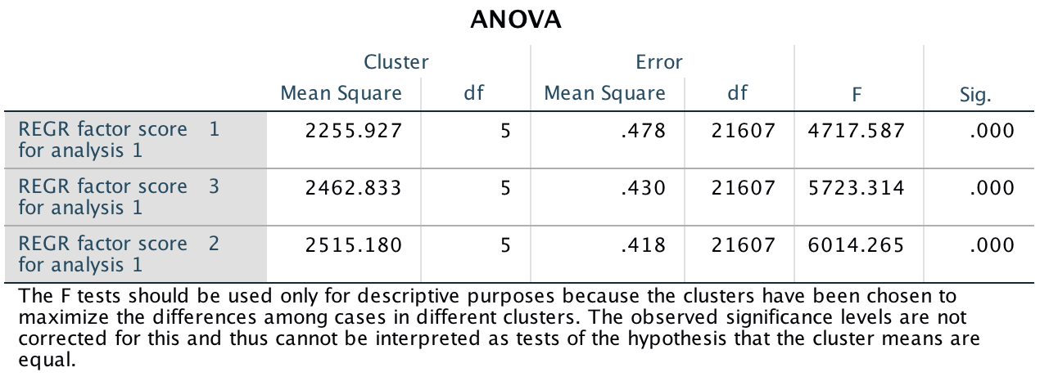

K-means is not a forecasting alghoritm, but we tried to understand in which cluster the house we used for the forecasting process in k-neighbour could be part of.

For doing this we calculate for every cluster the average value of the only “important” factors we found with the factor analysis ( in particular we are speaking about price, square feet leaving of the house, the zip code, waterfront and number of floors,

(possiamo analizzarlo come outlier)

possiamo calcolare l’errore che abbiamo sulle slide (quindi il rapport class variation on … )

possiamo calcolare the average price of houses in ognun cluster, e comporararlo col forcasted price del k neighbour alghorithm

usiamo le distanze per calcolare l’errore come between class variation